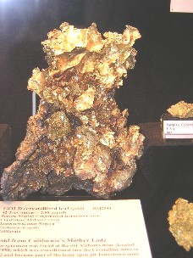  Nugget | Club Information  Ted Staley,  Ed Johnston  Reminders Calls:  Lynn Baustian  Treasurer:  Ouida Staley  Meetings:  2nd Tuesday Each Month  7pm – 9pm  Keizer / Salem Senior Center  930 Plymouth Drive NE  Keizer, Oregon
The January 17th outing was at the Rice Rock & Mineral Museum.
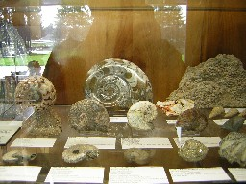
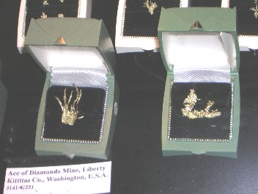
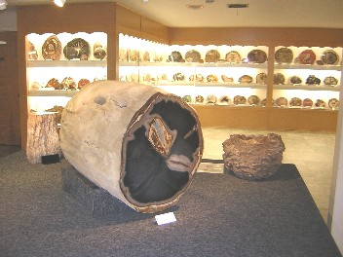
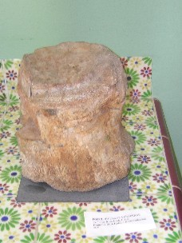
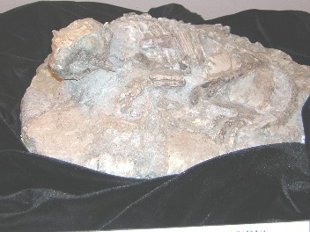
The exhibits were excellent and their volunteers were right on as to answering questions and giving of information. The new Northwest exhibit has been open for about a month. It is dedicated to rocks and minerals of the northwest.

Happy Birthday to You!!!!!  Claudia Wise  Larry Sheridan  Dan Wise | The Dredge has been paid for and picked up. This left the Club with $89.00  I have Closed the account with Wells Fargo Bank and opened a new one at West Coast bank. No checking fees and no limit as to the amount of Check’s Deposited. No more holding you checks forever.  Please remember that the meeting raffles are very important and if you have anything to bring it would be greatly appreciated.  Ouida

Feburary Outing
Feb- 11th Fossil Fest
At Hatfield Marine Science Center, All Day Event Open 10-4
We will meet at the Center at 9:45 am
Fossils and agate hunting after.
Gibby will take us to the best beaches for rock hounding and agate hunting.
Bring clothing to match the weather.
Hatfield Marine Science Center
http://hmsc.oregonstate.edu/visitor/vcservices.html
541-867-0100
2030 S. Marine Science Drive
Newport, OR
Driving Directions:
The Visitor Center is located on the Yaquina Bay in Newport, on the Central Oregon coast.
From Interstate 5: Take the Highway 34/Corvallis/Lebanon exit and turn west to Corvallis. Follow the Ocean Beaches signs through Philomath. On the west edge of Philomath, take U.S. Highway 20 and follow the signs to Newport. In Newport, turn south on U.S. 101. Take the first exit after crossing the Yaquina Bay Bridge and follow the signs to the OSU Hatfield Marine Science Visitor Center
U.S. Highway 20 is the more direct route from Philomath, but you may wish to take scenic Highway 34 from Philomath to Waldport and then turn north on Highway 101 to Newport. You'll see the signs for your exit to the Visitor Center before crossing Yaquina Bay; follow the signs to our parking lot.

Meeting Jan 17 2006
Gary Moore was the spokesman , the meeting was a general question and answer session.
This was well received with many interesting questions asked
- What is the best way to remove magnetite wet or dry?
There were many theories as to what is best 50/50 wet to dry, but the best suggestion was to make sure that you put the magnet into a plastic bag. This will make cleaning the magnates up much easer.
2.There is a web site www.49ermike.com that has many interesting links for information.
The Briggs Creek claim is open from June 15 to Aug.1
As a paid member you are welcome to use the claim.
A good inventory of mining supply’s
Oregon Mining Supplies /Rita’s Relics 1045 Main Street Sweet Home Oregon
541-367-2237 or toll Free1-866-367-4061
Joe Greene brought some of his rock collection , I think it was from one of his Az. Trips.

OREGON MINERS ALERT
January, 2006

The future of suction dredge mining in Oregon is in extreme danger!

On August 30, 2005, a coalition of environmentalist organizations filed a “Petition for Judicial Review” in the Court of Appeals of the State of Oregon. The Petition challenges the new Oregon suction dredge mining permit (700-PM) issued by the Oregon Dept. of Environmental Quality (DEQ) on July 5, 2005.
In their suit, the environmentalist’s claim improper conduct on the part of the DEQ while drafting the new permit, and that the new permit is not restrictive enough. It is believed by many in the Oregon suction dredge mining community that if Oregon Miners do not get involved in this litigation, they will ultimately get a more restrictive (and possibly prohibitive) permit.
The Eastern Oregon Mining Association (EOMA), with the help and support of the Waldo Mining District, Willamette Valley Miners, the Resources Coalition, and other mining organizations, has retained the services of noted attorney James Buchal to help protect the rights of suction dredge miners in Oregon.
On December 9, 2005, a “Motion to Intervene” and a “Petition for Judicial Review” were filed on behalf of the EOMA in the Court of Appeals of the State of Oregon.
The outcome of this litigation will affect all future suction dredging in Oregon, and possibly surrounding states.

YOUR HELP IS NEEDED!
We miners are battling for our very existence. We need ammunition, in the form of fifty caliber dollars, to counter this threat by the environmentalists (whose long stated goal is the prohibition of all suction dredge mining).
Please dig deep in your pocketbook and send your generous donations to:

EOMA 700PM Legal Fund

PO Box 932

Baker City, OR 97814

For more information contact Ed Hardt - President, or Chuck Chase – Executive Director, EOMA, P.O. Box 932, Baker City, OR. 97814. Copies of court filed documents can be viewed on the Waldo Mining District website at: www.waldominingdistrict.org
EOMA is a 501c6 non-profit organization. 100% of all donations will be used for legal fees in connection with this litigation, or possible future litigation.

Fellow miners,
The situation with the New 49’ers intervention in the Karuk vs. Fish and Game litigation is heating up and serious action is needed immediately by miners to ensure that this is a win for mining as we know it. This case has the potential to level the playing field for future attempts by agencies and organizations all over the country that are intent on taking our rights from us.
What does a court case in California have to do with miners who may reside in Oregon, Washington, Colorado, or any other state? Simply this; whether we win or lose, it will set a legal precedent that other courts will refer to in their decisions. It will also serve as case law that agencies will have to consider when writing new regulations.
Make no mistake; this case more than any before it, is winnable by miners. Even if we are not allowed to intervene, a successful lawsuit can be brought against Fish and Game. What has been done is illegal and we have everything in our favor for once.
Look at what we have going for us: Federal law has been violated (1872 mining law), state law has been broken, administrative procedures have been violated, and even county jurisdiction has been turned upside down. Not to mention the illegality of making secret deals between a state agency and special interest groups.
We can win this; but only if we are willing to fight!!! Our ability to fight is wholly dependant on raising the funds to continue. Without people willing to finance the fight, miners will lose and this will set a dangerous precedent.
There has been a lot of talk from miners in the northwest about the 1872 mining law, being proactive, and forcing agencies to adhere to the law. Now is the time to change the talk to action. It is easy to talk a good fight, but when it comes right down to it, talk never accomplished anything. Fighting a battle and winning it costs money. Just having the law in your favor will accomplish nothing if you are not willing to force the opposition to follow that law.
Miners handed the tribe their hat in their hand in the last Karuk litigation, which was a federal case. They then secretly and immediately filed this action in state court. We need to keep the ground we have gained. Miners everywhere cannot afford to let this opportunity pass. This is an unusual opportunity to force an agency to follow the law and prove to agencies and special interest groups that miners can and will fight when attacked.
The same environmental groups that have lost the last two major lawsuits in both California and southern Oregon are behind this new litigation. The same tired old arguments they used then are being used now. There is one difference, now they are using flimsy arguments that can be seen as acts of “desperation” on their part. They are either simply not true or are arguments that are nothing more than statements with no way to prove them. Here is what Dave Mack of the New 49’ers wrote about this situation:
http://www.goldgold.com/newsletter012006.htm
The bills for attorney fees have begun to roll in, they are substantial. The attorneys have done a lot of work last month and it was excellent work. The legal costs will escalate once the actual court proceedings begin. We need to prepare for funding this increased activity. I went to the office today and examined the legal fund books at Dave’s request. Probably due to the holiday season and money being tight when this mess began, donations have been slow. We have taken in about half of what our attorney’s bill was to this date.
Last year the donations for that Karuk lawsuit poured in in record time. When the suit ended, we were a bit behind but miners came through and it was quickly caught up and paid. This, more than anything else, was what allowed us to respond so quickly in this lawsuit. As far as the attorneys were concerned, we were a known commodity and they were willing to take this on for us, knowing we would perform as we had before.
We have a champion willing to take the responsibility to initiate our lawsuit and see it through, his name is Dave McCracken. He has worked quietly behind the scenes for many years, dealing with agencies in our behalf to get reasonable regulations. He gave many hours of his time to meet with agencies, tribal leaders and others. He never asked for any compensation for this and it was substantial work and very time consuming. Now he has taken on a battle for all miners, not just club members. Remember that the streams that have been closed by DFG in California contain more than just club claims, these streams have many individual and company claims that will be forced out of the water. In fact, everyone is forced out of the water on certain streams right now, it is a done deal unless we can turn it around and I am convinced that we can turn it around.
The odds, the law, and the science are all in our favor. This is a state agency caving in to special interests as well as taking private property without compensation (mining claims are private property). This settlement was done behind closed doors and this needs to be exposed to the light of day.
For once the average miner has a tool to rein in an out of control agency and fight back against a special interest group effectively. Let’s not lose the high ground, let’s keep up the momentum we have gained in the previous Karuk litigation as well as the SREP suit on the Oregon side of the Siskiyous. These are wins that will serve us well in years to come, because they are “case law” that courts will refer to.
The attorneys are doing a fantastic job, but they need to be paid. Let’s all chip in and do what we can, no matter how small or large the donation. We are donating to our own fight here. Our ability to keep mining and to stop other special interests from doing the same thing in other places hangs in the balance. The financial help of all miners is needed now. The more miners we can make aware of this, the better and less costly it will be for each of us. You can send your donations by mail to:
The New 49’e LegalFund P.O.Box47, HappyCamp,CA 96039.
Or you can go here http://frost.bbboy.net/thenew49ers and click on the white “make a donation” button at the top of the forum to donate by credit or debit card.
Jim
Administrator
New 49'ers Forums

