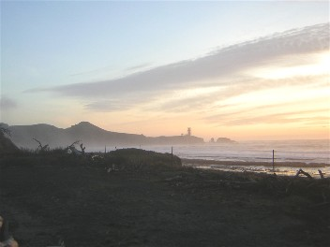  February Beach Outing | Club Information  Ted Staley,  Ed Johnston  Reminders Calls:  Lynn Baustian  Treasurer:  Ouida Staley  Meetings:  2nd Tuesday Each Month  7pm – 9pm  Keizer / Salem Senior Center  930 Plymouth Drive NE  Keizer, Oregon

March Meeting Change

Presented by Dan Williams—On Metal Detecting and Detector use

Please bring your Detector and Dan will show how to set and use them.
We will be Meeting at Willark Park on 14th Ave NE in Keizer
.Between 5:00 & 5:30PM. Weather permitting
If it is raining we will meet at the Sr.Center at 7:00pm as usual. Still bring you Detectors.
Directions: Get off the Freeway at the Keizer ext. Go right towards town,down Lockhaven To 14th. Third light. At the corner of the Mormon Church. & 14th Turn Right, Go down 14th to Just pass the first stop sigh up a little hill and on the right is a short street “ Mandrin Ct”. At the end is the Park..
Our Truck will be parked on 14th with a MD sign.

Happy Birthday to You!!!!!  March  Marlea Sheridan | Finances:  Balance Forward 148.70  Deposit 2-14 313.00  Feb Meeting Raffle 33.00  Membership Renews 85.00  Donation 350.00  Checks - 21.55  Envelopes -2.00  Stamps -16.35  Sr. Center Use Jan & Feb -40.00  Total +849.80

GPAA GOLD SHOW  March 11 &12 2006  Fair Grounds  Salem Oregon | No Outing March 18th.

February Meeting
By Lynn Baustian

Hello there fellow Diggers
The meeting was called to order promptly at 7:00pm.............or something like that and roll call was taken ................sort of, and we had a couple of new visitors. Hopefully Elison and Kirk will join our ranks and we will have someone else to
pick on. It was nice to see a couple of faces that have been missed at some meetings and great to see Larry Sheridan up and walking again.
Ted Staley, our spokes model, asked for a treasurer’s report and it is reported we have money!
Ouida reported we have at least a buck or two and if we can sell a few more tickets at the next meeting, we might have at least ten bucks eventually.
Under new business, old business, the subject arose about club hats, shirts, and patches or transfer stencils to which Claudia Wise will check into and report back. Hopefully this information will be available at next months meeting.
Our lovely spokes model then turned the meeting over to Kent Gibson. The meeting was grand with an exceptional oration given by Kent on fossils. How he found enough wind to keep the meeting going close to 9:00 PM I don’t know but he answered everyone’s questions and pleaded the Fifth Amendment at the appropriate times. Kent gave a tour, something we don’t often get at meetings, and it was a lovely trip.....................to the back of his pickup. There were some gigantic fossils that were too big bring indoors and a couple of un-fossilized things that must have drifted to our coastline. Kent said one looked like a plastic Japanese property marker (I think) and there was no way to disguise the two brown bottles but I suspect he will try to collect the Japanese bottle deposits.
Lynn Baustian brought in a faceted blue gem he made from a broken antique glass insulator, which Delmon Ray furnished at last months meeting. Also Lynn had a partially faceted sunstone that was still in the works. Brian Watson brought in a plate of delicious cookies his mom made and needless to say, the plate went home empty. Thanks Brian and tell your momma thanks too!
The monthly drawing was held at the end of the meeting and there were some great items to pick from. Seems to me there was a bottle of wine, with croissants and a bottle of SAKE too! No one shared them like Brian did but that’s OK (not !) and there was even some chocolate cake and desert kits in a jar (I think that’s what they were) some independent mining journals, a gold pan kit and a dog collar. There may have been something else but I can’t remember what it was
At this time we would like to remind those that have not paid there yearly dues to please take care of it ASAP. We will soon need money’s to pay for our claims and the majority comes from membership dues so it is very important. As of April 1, 2006 those members who haven’t paid will be dropped from the phone reminder list until their dues are paid.
Hope to see ya all at next months meeting!
Tualatin Valley  Gem & Mineral Show  March 10 9a-5 p  March 11&12 10a-5p  Washington County Fairplex  NE Cornell Rd.  Hillsboro Oregon  Admission 1.00 12 & Older | Sweet Home  Rock& Mineral Society  Rock & Gem Show  April 1 10a-6p  April 2 10a-4p  1641 Long Street  Sweet Home Oregon  Admission .50 | Mt. Hood Rock Club  Rock, Gem &Craft Show  April 8 10a-6p  April[ 9 10a-5p  Mt Hood C.C.Gym  260000 SE Stark  Gresham Oregon  FREE Admission

February Outing

February 11th was our outing, we met at the OSU Hatfield Marine Science Center, Newport.
The Annual Fossil Fest going on with fossil identification, displays, fossil swap and a talk by Guy "Oregon FossilGuy" DiTorrice.
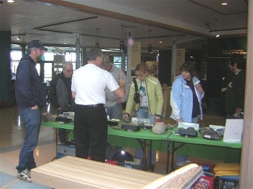
We stayed to listen to the seminar from Guy DiTorrice. After lunch the next seminar was given by Dr. Orr. He stressed that in nature there is always a symmetry Meaning what you have one side you will have on the other.
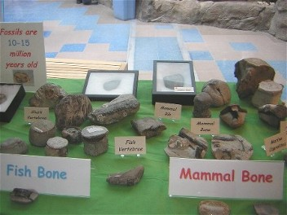
After the lectures we went down to the beach .The tides were going out and there was little sand. Everyone went out looking, Lucy and I found some agatized snails. This happens when silica enters the shell and you get a clear agate shaped like the snail.
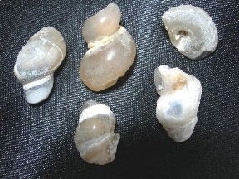
I found for the first time a
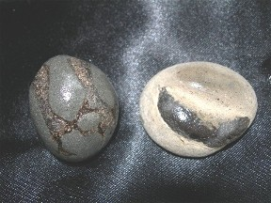
few vertebra fossils
probably from a fish
Also found was
fossilized
seal pooo. Go figure

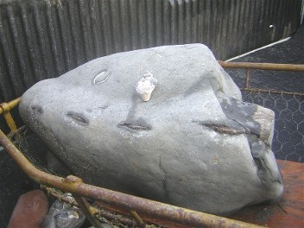
Gibby found a few whale vertebras. It took three men to bring them to the truck. They carried it up on stokes litter.
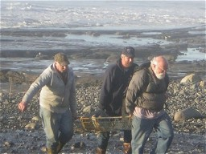

The Day was a lot of fun and by finding agates, fossils, and pooo
