May 9th Meeting  Will have a Guest Speaker  Mr. Dave McCracken  The meeting will start Promptly at 7:00 PM  We will have to be out of the building by 9:00PM  The Millennium Diggers Club will provide FREE Coffee and a Sweet.  There will be a $3.00 cover charge for non-members to help defray the cost of the building | Club Information  Ted Staley,  Ed Johnston  Reminders Calls:  Lynn Baustian  Treasurer:  Ouida Staley  Meetings:  2nd Tuesday Each Month  7pm – 9pm  Keizer / Salem Senior Center  930 Plymouth Drive NE  Keizer, Oregon

March 13th Meeting
Guest Speaker was Dan Williams on how to set up and use a metal detector. There were as many questions as there were metal detectors at this meeting. The outing to Willark Park was rained out. Oregon gold is very deep so most machines have trouble finding it. Good places to look are in creek and rivers cracks when the water is low. The sweep speed if you are using a gold machine is a little faster and do not arch at the end of the sweep. Paul B. asked about salt water detecting and this takes a special machine for underwater. If you use your machine be sure to keep the controls dry & rinse well after use. When hitting on a target go up & down then side-to-side if its trash it will zip only one way. All in all there were wonderful questions and answers were from everyone and a lot of good stories too!!

Happy Birthday To You!!!  April: May:  Delmon Ray Amber Parker  Brian Watson Ron Dixon  Barbara Parker Dave Cacka  Fran Krohling  Sara Wise  Ouida Staley | Finances:  Balance Forward 849.80  March Meeting Raffle 31.00  Memberships March & April 245.00  April Meeting Raffle 22.00  Sr. Center Use March -17.00  Sr. Center Use April -22.00  Total + 1108.80
April Detecting Outing Rained Out
But 5 people tried.. We spent 20 minutes detecting before we were all frozen. Thank you Gary Moore for letting me try your machine. It did help (I can’t hear the zip-zip). I have been practicing a little.
Barbara Parker, Amber Parker, and I went on to Ed’s House of Gems. Then we picked up Mike Parker and went to the Polk County Rock show where we ran into another club member, Dan Williams. Delmon went to have a tire fixed. So Fun! See you all at the next meeting.
Ouida

May Outing 27-29, 2006

Plush Oregon SunStone Outing

ABOUT OREGON SUNSTONE

Oregon sunstone is a feldspar crystal formed in molten lava and then discharged onto the surface of the earth by a volcano. As the lava weathers away or is broken up the crystals are released.
While feldspars are found all over the world, they are rarely gem grade. Oregon is one of the few places where this type of feldspar is found in gem grade and large enough to cut stones for jewelry.
Oregon is also the only place in the world that this gem grade material is found with copper in it. Varying amounts of copper cause the stones to range in color from water clear to yellow, as well as many shades of green, red and pink. Some stones contain from two to four of these colors. Some rare stones will even change colors in different light as alexandrite does, and some are different colors when viewed from different directions (dichroic and trichroic).
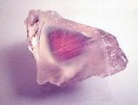
Many sunstones also contain copper or pyrite inclusions that cause an extra flash or shimmer as millions of the shiny aligned particles reflect light. This feature is called "schiller". Schiller has a wide range of shapes and intensities, depending both on the original stone and on how the artist orients it during cutting.
Schiller may appear like the snowflakes in a toy glitter-globe It may appear as stripes of pink or copper-colored reflections, Or, it may be so dense as to appear like a solid sheet of copper within the stone. Due to the way schiller is formed, every stone with this feature is truly a one-of-a-kind creation, and the effect is often stunning.
Oregon sunstone, found only in the remote high desert of Lake and Harney counties, It was officially named the Oregon State Gemstone by Governor Neil Goldschmidt and the Oregon legislature in 1987. Since that time Oregon Sunstone has been gaining popularity with collectors, artists, and jewelry lovers everywhere. It is now one of the leading gemstones mined in the U.S.
Each Oregon Sunstone is much more than a pretty stone or item of jewelry. It is a piece of art, a piece of history, a piece of Oregon.
SUNSTONE LORE:
In ancient times, sunstones were used by natives for barter, They were thought by the Vikings to be a talisman for navigation. New age thought links sunstone to protective energy. It is also said to lend extra physical energy in times of stress or ill health. Others claim that sunstone can assist contemplative processes and bolster the energy level.

We will be camping on the BLM area. This is a no fee Sunstone area.
There is a restroom but no water. So bring plenty.
Saturday night will be “The Potluck” bring a dish to share that will feed five.
The club will be providing Hotdogs and Hamburgers, and all the condiments.
We will be mining at the “Dust Devil Mine“. Most stones are free but colored stones may cost. The amount will depend on the quality of the stone.
The Dust Devil Mine is about 1 mile from the camp area.
Bring plenty of water to drink and sun screen.
Tools: Hammer, Small Pick, Shovel, Small Pry bar, and a bucket for your sunstones. Ted made a Classifying Screen last year. The Mine provided shaker tables on a first come first serve.

Directions from Lakeview:
Drive north about 6 miles. Turn right on Hwy 140. This intersection is well marked for the Warner Mt Ski area and Adel. Drive 16 miles east on Hwy 140, then turn left on CR 3-13 toward Plush. This intersection is well marked for Plush, where you should top off your fuel tank and pick up ice, beverages, and snacks before continuing north on CR 3-10 also known as Hogback Road. It is the main road running through Plush. The pavement will end after 5.5 miles. Drive another 5.5 miles to the intersection with CR 3-11 and turn right Go ½ mile and turn left at the intersection with BLM 6155, which is marked by a decaying sigh that once read SUNSTONE. Drive 7 miles and turn left at the intersection with BLM 6115, which is well marked by a sign pointing the way to the Sunstone collecting area.

Directions from North On 395:
When traveling from the north on Hwy 395, turn left on Hogback Rd milepost 64. During dry weather, high clearance vehicles may turn left after 7 miles on unmarked Nasty Flat Rd. Drive 7 ¼ miles then turn right on BLM 6115. In wet weather or in low ground clearance vehicles travel about 20 miles south on Hogback Rd. Turn left on cr-3-11. Turn left at the intersection with BLM 6155 and left again at the intersection with BLM 6115. Travel 5 miles to the mine.

Barbara & Amber Parker
Amber’s Treasures Delmon Ray Gary Moore
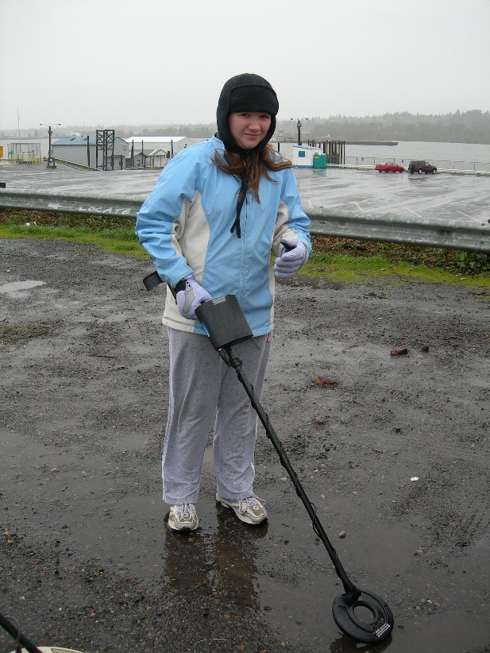
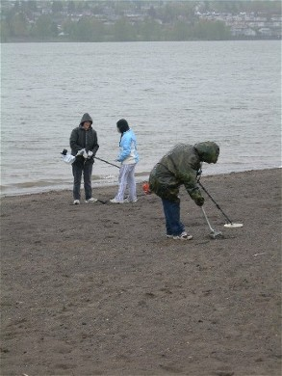
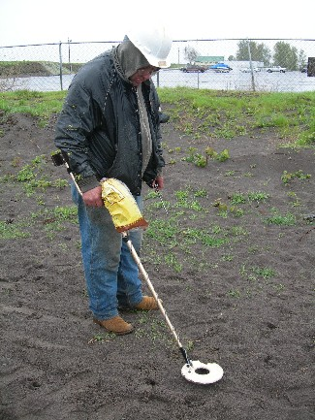
April’s Very Wet
Outing……….

A Very Big Thank You to Lynn & Alice Baustian
For the Pizza and Coffee at the March meeting. ☺

Map to Plush
“Dust Devil Mine”

