  A Fitting End | Club Information  Ted Staley,  Ed Johnston  Reminders Calls:  Lynn Baustian  Treasurer:  Ouida Staley  Meetings:  The Gathering Place  7845 River Rd N  Keizer OR  2nd Tuesday Each Month  7pm – 9pm

ATTENTION

Our Meeting Place Has Moved
It will not be at the Senior Center any more

Note the New Address
The building is Grey With a large White Sign in front that says
The Gathering Place
Going North on I-5 get off the Keizer exit go over the freeway
Turn left go down Lock haven to River road,
Albertsons is on the left Turn Right go 3-4 miles on River Road its on the left.
If you get off the Exit at Brooks
Go right on Brook lake Road At the RR tracks and stop sign go left
(This is River Rd) about 4-miles
And it’s on the right going south-bound.
I am not good with distance so I hope I am close.
It was a Grange Hall and a church at one time.
We will need to make sure that the Hall is returned to the same as when we arrived.
Pick up and put chairs and table away.
Thank you all, see you at the outing

June 24, 2006
The June Meeting Will be Hosted By Delmon Ray
Subject is Getting ready to Dredge
The Outing will be at Quartzville
We can meet at the McDonalds in Sweet Home at 10 AM

Or if you want to go earlier or later we will be at the Rock Quarry.

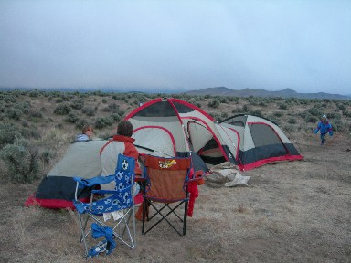
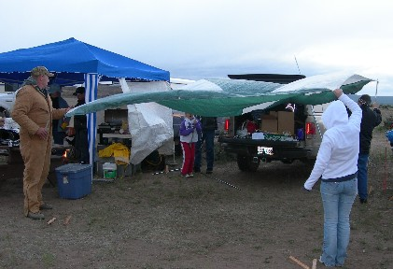
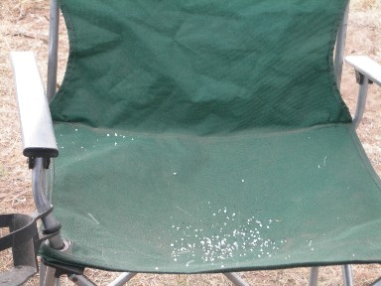

June Birthdays  Emmaleigh Johnston Fred Ahl  Buzz Sizemore Robin Callander  Mike Parker | Finances:  Balance Forward 1108.80  Sr Center May Meeting 39.00  New Membership 45.00  Donation 5.00  Albertsons Sunstone Outing - 15.60  Walmart Sunstone Outing - 20.36  Total 1161.84
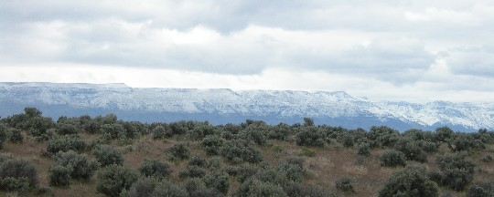

May Sunstone Outing
Well I have to say we had a blast. The weather was typical for an outing, Cold And “Snow” Well It was a dry rain…
The First day, Friday we went to the Dust Devil mine and found that the pit was still mostly filled.
There was some digging but no one was finding much. The day was overcast but not too cold.
The second day we all woke up to find it snowing just a little
Mostly every one sat around the fire as you could, the wind was bitterly cold. We all took up residence under the tarps to get out of the cold wind.
Saturday night we decided to have the Potluck anyway and it was a great success. Everyone looked a little like Eskimos in their Carharts and many layers of clothing.
As evening went on the wind died down and the fire was wonderful and warm.
Kathy Talbot found that at the Spectrum mine you could dig for 2 days and keep all the stones you found and you could use the conveyer for 20 minutes free and keep everything. After that it was $100.00 an hour but you keep what you get no extra fee.
Many of the Diggers did this and some large stones were gathered with shiller being the greatest find. There were many reds, watermelons, and a few greens.
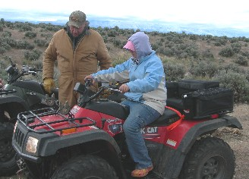
Monday was a nicer day and quad rides were in order. Amber Parker, age 11, was introduced to quading and went for her first self-drive. She did great.. Shayanne, age 5, and McKenzie, age 8, both learned to drive quads this weekend too. What fun the kids had.
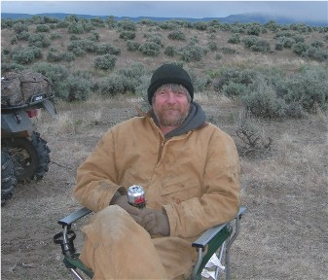
Gibby did his usual walking the area and brought back pocketfuls of stones. He could find rocks in the dark with both hands tried behind his back and blindfolded. What eagle eyes he has.

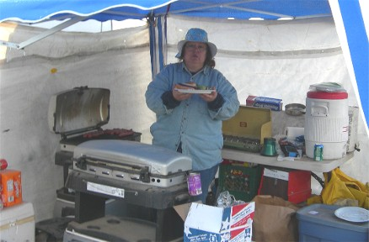
Alice Baustian was our cook for the potluck How smart was that, she stayed warm and dry. Another Millennium Digger Outing.
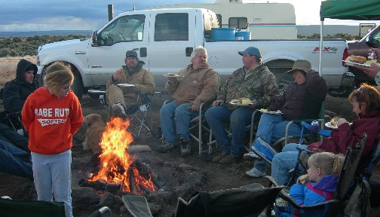
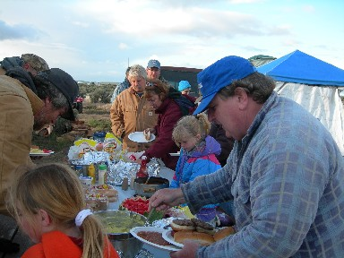
The Dinner

