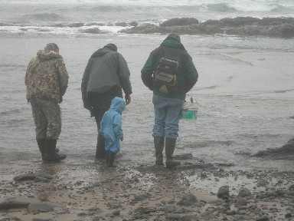 | Club Information:  Ted Staley  Ed Johnston  Reminders Calls:  Lynn Baustian  Treasurer:  Ouida Staley  Newsletter/Website Editor:  Barbara & Amber Parker  http://www.millenniumdiggers.com  Meetings:  The Gathering Place  7845 River Rd N  Keizer OR  2nd Tuesday Each Month  7pm – 9pm

Our meeting place has moved. It will not be at the Sr. Center anymore. Note the new address.

2007 Club Dues

It’s that time of year again – time to pay your 2007 club dues. If you haven’t paid yet, please see Ouida at the next meeting or send your dues by mail.

Special deal for 2007 -- If your referrals to our club result in 3 new memberships in 2007, your 2008 dues will be FREE!

February Meeting

Ferman spoke about metal detecting in our area. He discussed the changes he's made to his website NW Treasure Hunters. He talked about the importance of digging a clean hole when metal detecting. It's important to leave an area much the same way you found it to respect the owners and other users. It's also good to dig a plug that's at least a couple of inches. If your plug is too shallow, lawn mowers will pull them out and leave a divet. Ferman showed us his shovel he likes to use for digging. It's called a Ground Shark made by Leshe.

We talked a little about the TV show Cash & Treasures and the episodes about locating old bottles in outhouse sites. We all wondered where to get ahold of the Sanborn maps for this area.

Fossil Fest

The Hatfield Marine Science Center in Newport sponsored Fossil Fest again this year. Several members of the club attended this event. There were several displays of fossils. They also offered fossil identification. Dr. William Orr of the University of Oregon gave a presentation with a slide show on fossil insects. He indicated it is almost impossible for an insect to form a fossil because the soft structure of the insect typically rots before the fossil forms. After Dr. Orr’s presentation, several members went to the Moolack Beach area to go on our own fossil hunt.

March Meeting

Gibby brought in just part of his fossil collection. He explained what most of the pieces were and where he found them. He shared some books that he likes about fossil identification.

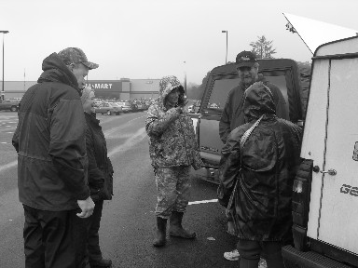 | 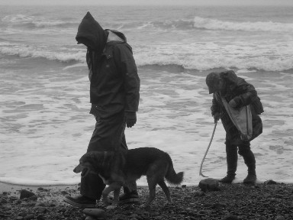 | 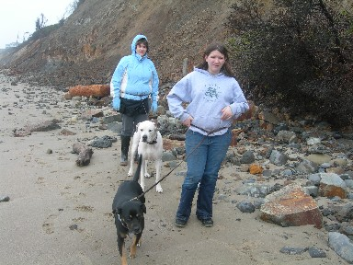

March Fossil Hunting

Fossil hunting in Newport was great!! We found lots of interesting stuff. Agatized snails, fossilized snails, petrified wood, and agates just to name a few. The weather was good, not too cold, a little foggy and a little bit of a mist.
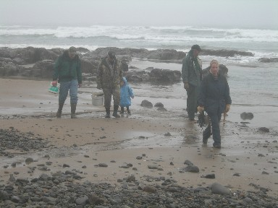 | 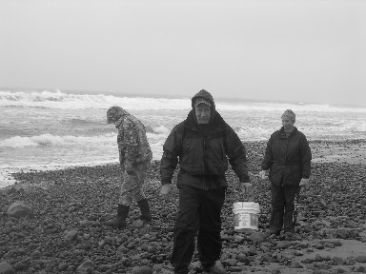 | 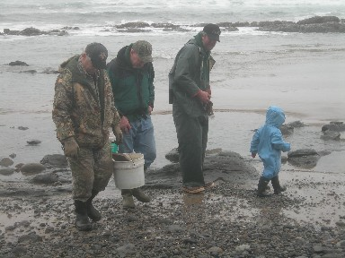

March Metal Detecting

Ferman hosted a metal detecting outing to the Dallas City Park. The weather wasn’t too bad, a little bit of rain, but Ferman was the only one to show. Maybe once the weather clears up, we will all get over our fear of rain and join Ferman. Too bad you didn’t come, Ferman found some good stuff! 68 pennies, 5 nickels, 13 dimes, 7 quarters, 1 Sacajawea Dollar, a 1915s wheat, a 1901 Barber dime, 3 rings (one is silver), and an interesting little bell.

April Meeting

The meeting started with Ted giving the members info on the club’s new claim on Briggs Creek. Sorry I can’t remember the name. Anyway after that the meeting was turned over to me. For your information each month a member volunteers to host a meeting on a subject that he or she has the knowledge of for the good of helping any or all of the club members. My idea was to try to help any and all of the members with their metal detectors. The idea was to show the members how and why a detector works. So I took a 5 gallon bucket drilled holes at different depths from about 2 inches from the top the next at about 4 inches with 2 more at about 8 inches and at the bottom. Through these holes I put plastic pipe. Next I filled the bucket with a mixture of dirt and gravel. Next was the task of getting some paint stirring sticks. To these I glued coins and various other items so that they could be passed through the pipes to see how the various member’s detectors would react to the different items.

After a brief explanation by me of the purpose of the bucket and items everyone was asked to come up and see how their detector would react to the different items. They came up and began to use the bucket. Some members showed others how to set their detectors and how they should work. Everyone was helping each other. I answered any questions that came up as best I could. Hopefully everyone learned something about his or her equipment. I was very happy with the participation by all. Anyone who is new to the club I will be happy to make the bucket and stick items available at any meeting in the future. And any help I can to any member.

TIL THEN GARY J MOORE

THE GATHERING PLACE
A SMALL VENUE FOR

SPECIAL EVENTS
503-393-1558
WEDDINGS, ANNIVERSAYS,
BIRTHDAYS & HOLIDAY PARTIES
ENJOY
Capacity up to 100 guests, kitchen, service bar, stage.
Piano and open hall with wood floors, bathroom
Wheelchair accessible.
Use both the building and the garden area for your special event
Hourly rate: Mon-Fri Daily Rate Sat –Sun
Book your special event today





