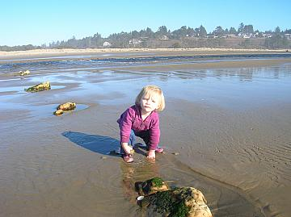  One of our younger Diggers | President - Delmon Ray  Vice President - Tom Callander  Secretary - Barb Parker  Treasurer - Joe Greene http://www.millenniumdiggers.com  Meetings:  Roth’s - Keizer  5013 River Rd N  Keizer OR  2nd Tuesday Each Month  7pm – 9pm

NEEDED – Outing Photos
To supplement the few taken by the newsletter editor.

January Meeting – 1/13/09

Joe took a trip to Maine and visited a tourmaline mine. He talked about the mine, what he found, and passed around samples.

Potential outings for 2009:

January 18 – Rock hounding in Newport

February – Tour of White’s Metal Detecting, Sweet Home

March 28 & 29 – GPAA show

April – Fossil hunting at the beach with Gibby or the Rickreal Gem show

May 23 thru 25 – Sunstones or Glass Butte

June 13 – Quartzville dredging

July 4 through 6 – South Umpqua dredging

August 15 thru 16 – South Umpqua dredging

September 5 thru 7 – Briggs Creek dredging

Oct 18 – metal detecting

November 15 – TBA

December 5 – Christmas dinner

January Outing – 1/18/09

We met at the Walmart in Newport at 10:00 am on a bright and beautiful Saturday. From there we caravanned to Ona Beach, south of Newport. Some people took their metal detectors; others just took their rock hunting gear. The temperature hovered around 63 to 65. It was definitely t-shirt weather. The water was very cold and near the bank under the overhang of trees, you could see the remnants of the previous night’s frost.

I heard of no good finds with the metal detectors, just a few pieces of junk metal. Delmon found some blue agates (as usual). Several clear agates were located as well.

February Meeting – 2/10/09

Our guest speaker, Howard Connor, Willamette Valley Miners, spoke about Safe Handling and Mercury Cleanup using a Retort.

The club is researching a new claim.

February Outing – 2/14/09

We met at the Keizer Albertsons at 10:00 am. From there, the group went to the Methodist Church on Wheatland Ferry Road. One of our members received permission from the church to metal detect the grounds and some adjacent church owned properties. The sky was pretty clear but the wind was very cold. Several coins were found and lots of junk metal (rusty razor blades, small engine parts, large washers, bolts, etc.)

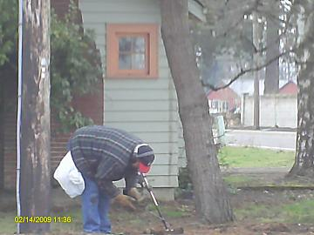 | 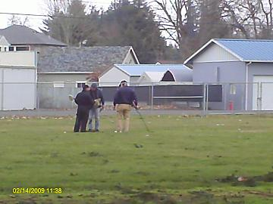
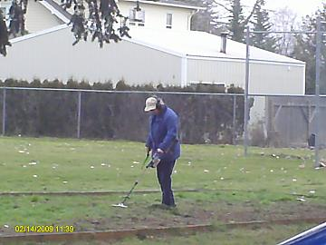 | 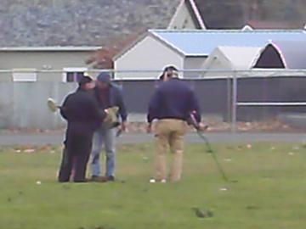

Barb Parker
Millennium Diggers Secretary

