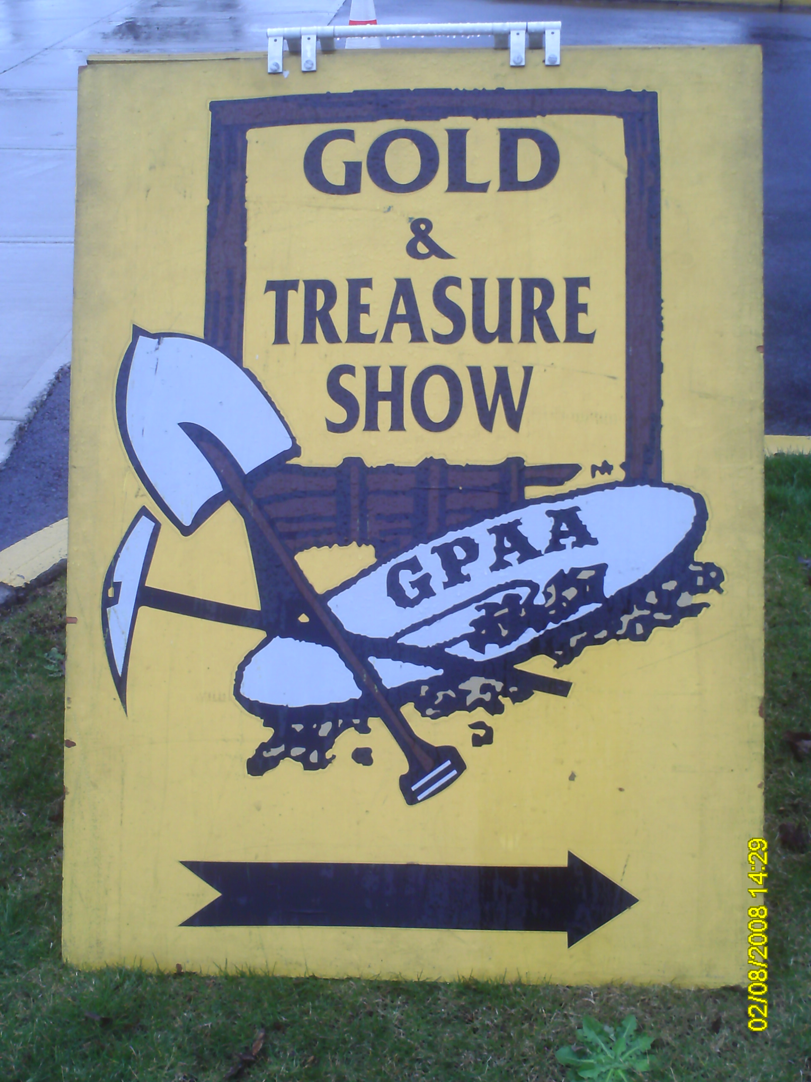 | President - Delmon Ray  Vice President – Tom Callender  Secretary - Barb Parker  Treasurer - Joe Greene http://www.millenniumdiggers.com  Meetings:  Roth’s - Keizer  5013 River Rd N  Keizer OR  2nd Tuesday Each Month  7pm – 9pm

Obituary

Tom Callender passed away suddenly on April 29, 2009. Tom took over the job as Vice -President of our club this year with enthusiasm and a will to hit head on his fear of speaking in front of an audience. He was making plans to increase club funds with new ideas for a club fundraiser. He was an avid stock guru and had planned on presenting the club with some of his tips on making it big in the stock market. He was a good friend to all; we will miss him very much.

March Meeting – 3/13/09

Our president, Delmon, was our guest speaker for the month. He spoke about his gold extraction methods. It was very informative and was enjoyed by all in attendance.

March Outing – 3/28/09 – 3/29/09

The March outing was the GPAA Gold Show at the Oregon State Fairgrounds. Approximately 10 members were able to attend the show. The GPAA sponsored gold show highlights new mining technology and provided a place for folks of similar interests to get together and talk of the upcoming mining season. Many venders were present to answer our questions and sell their wares. Although, this year there didn't seem to be as many tables as usual. The members that attended ran into other club members and mining buddies from other groups and all had a good time.

April Meeting – 4/14/09

Joe announced that we had plenty of money in our treasury and could reduce our membership fees in half. Delmon called for a motion, which was seconded and voted on by the membership present. The motion was approved. Our new membership fee will be $20 per year. Those who have already paid $40 this year will have their membership extended through 2010.

Our guest speaker was our treasurer, Joseph Greene. Joe took a trip through Arizona and Nevada and did some rock hounding while he was there. He demonstrated how some of the rocks fluoresced under short and long wave black light. They were aglow in shades of red, blue, and green. Joe brought lots of samples back to share with us…we even got to take some home.

April Outing – 4/18/09

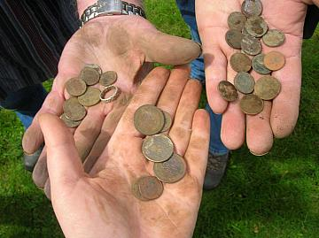
Ferman arranged a metal detecting outing to Cascade Gateway Park. Members detected just past the bridge after Walther Wirth Lake. Not a lot of junk metal, several coins, four carwash tokens, and a little silver ring were located. The weather was perfect and the park was not crowded at all. As you can see by the dirty hands in the picture, the digging was fairly easy because the ground was still a bit wet.

Barb Parker
Millennium Diggers Secretary

