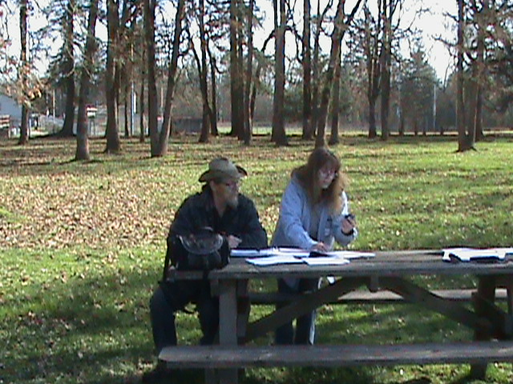 | President - Delmon Ray  Vice President – Claudia Wise  Secretary - Barb Parker  Treasurer - Joe Greene http://www.millenniumdiggers.com  Meetings:  920 Marks Dr N  Keizer OR  2nd Tuesday Each Month  7pm – 9pm

NOTE – New Meeting Location
We have a new meeting place. We are now meeting at the United Methodist Church, 920 Marks Dr N, Keizer. Take River Road north and turn left on Wheatland. The church is a couple of miles down on your right. There’s a sign out on the road. Pull into the parking lot and go to the back. You’ll see a double-wide manufactured on the right side with the lights on. That’s us! Come on in!

January Meeting – 1/12/10
We spent a good part of the January meeting brainstorming ideas for outings and speakers. We came up with several ideas; it looks to be a great year! Just a few of the items discussed:
- Speakers from Metal detector companies
- Black sand box demo
- Sunstones
- Forest Ranger
- Fossils and agates at the beach

February Meeting – 2/09/10
We decided to bring rocks/minerals to share at each meeting. Our February assignment was to bring items beginning with the letter “A”. We had an entire counter full of gorgeous specimens: Agates, Apache Tears, Amethyst, etc.

Claudia and Joe updated us on the Karuk Indian Tribe vs. California Department of Fish and Game lawsuit. They have been invited to serve on a public advisory committee that will direct the environmental impact study.

February Outing – 2/20/10
We had a joint outing with Willamette Valley Miners at the park next to Morningside Fire Department on Cordon road. Boyd from Willamette Valley Miners gave a great talk on how to use a GPS and how to find a geocache. Members then went out and practiced their newly acquired or newly enhanced skills.

ICMJ’s Prospecting Journal – March 2010 Edition
Battle Heats Up Over California Suction Dredging – by Scott Harn
Things are progressing in the fight to restore the rights of suction gold dredger in California.
The State of California is seeking dismissal of the federal lawsuit filed by Public Lands for the People (PLP) on grounds that they are immune from such lawsuits under the 11th Amendment to the US Constitution. However, there is plenty of prior case precedence suggesting that state officials and agencies are open to such lawsuits when they assume responsibility for regulatory authority from the federal government. There is also plenty of case precedence addressing the culpability of officials for ignoring rights granted by the Constitution and acting contrary to established laws. The federal regulations and prior court decisions make it clear that mining is subject to reasonable regulation, but cannot be prohibited on public lands open to mining claims. We pray the judge will have the wisdom to make the correct decision when the facts are presented the first time.
Both sides are scheduled to present their cases on February 25, which is after this issue goes to press. We would expect the judge to take the matter under submission, but not to take too long to issue a decision – a hearing on PLP’s injunction to prevent the state from enforcing SB 670 has already been tentatively scheduled for March 25.
PLP also filed their appeal to the injunction issued by Judge Roesch in Alameda County Superior Court that prevented the Department of Fish and Game from spending any funds on the dredge permitting program pending the completion of a new Environmental Impact Report. A court date has not yet been set for the appeal.
In the meantime, the Department of Fish and Game (DFG) continues working toward the completion of a new EIR on suction gold dredging. Many readers have reported receiving surveys from DFG. At the urging of some suction gold dredgers, DFG has established a small working group representing interested parties to provide direct input throughout the EIR process. Several environmentalists are included in this group, but we were relieved to see that our interests are well represented. While we don’t have the entire roster, we have confirmed that Jerry Hobbs (PLP), Pat Keene (Keene Engineering) and Jim Foley (New 49’r’) are part of the working group. Siskiyou County has been outspoken in their support of suction dredge mining and is represented by Ric Costales and Ken Oliver.
But I think the most important members of the working group are not miners nor county representatives, but rather two retired scientists. Claudia Wise and Joseph Greene have extensive experience in biology, fisheries management and water quality. Ms. Wise was a physical scientist and chemist who retired after 32 years of service with the EPA. Joseph Greene has 30 years experience and retired as an EPA research biologist. Their resumes give them a high degree of credibility while their retirements allow them to speak freely and honestly without repercussions. These two have been providing constructive comments on suction gold dredging legislation and regulations for several years. Both have shared their professional opinions that suction gold dredging provides its own mitigation including numerous benefits for aquatic environments, and both have publicly stated numerous times that suction gold dredging is a de minimus activity. They also have been able to refute much of the propaganda from environmental extremists.
The most unfortunate part of this mess is that suction dredge gold miners, like much of the population in California, need reliable work to provide food, shelter and other necessities for their families. With high unemployment and a gold price well over $1,000 per ounce, it’s a perfect time to create wealth through responsible mining.
We will continue to keep you posted as new developments arise.

Barb Parker
Millennium Diggers Secretary

