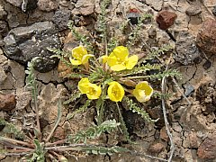  Lake Bed of Flook Lake | President - Delmon Ray  Vice President – Claudia Wise  Secretary - Barb Parker  Treasurer - Joe Greene http://www.millenniumdiggers.com  Meetings:  920 Marks Dr N  Keizer OR  2nd Tuesday Each Month  7pm – 9pm

May Outing
Over Memorial Day weekend, club members enjoyed some beautiful weather outside of Plush, Oregon at the Sunstone Collecting Area. Penny and Walt even found Sunstones around Abert Lake. Barb and her family paid for a pre-sorted scoop of material at the Double Eagle Mine. They presorted the material right in front of us and dumped the smaller stuff on screened tables so we could go through it. We found lots of the champagne colored stones but nothing with color. Fred and his wife also visited the Double Eagle Mine but opted to dig through the piles of material straight out of the pit.

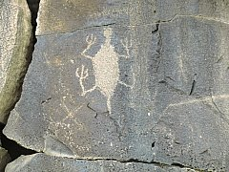
After sifting through the dirt for two days, Barb and her family visited the Hart Mountain Antelope refuge. They found jasper, agate, petrified wood, quartz, and more on the dried up bed of Flook Lake. They also hiked out along the edge of Petroglyph Lake to get some good shots of the old Indian drawings.

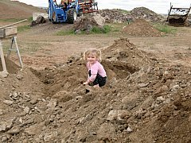 | 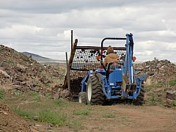
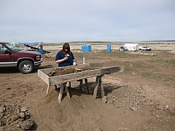 | 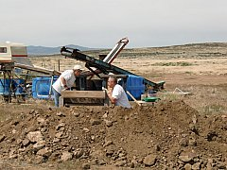

June Outing
Several members showed up at Moolack Beach bright and early the morning of June 12th. This was to be a good day for rock hounding, as there was a low tide that morning. The weather was clear, about 62 degrees, with just a little wind. We found agates, fossils, and some red jasper. Delmon found a clear agate with water inside. Ferman got out his metal detector but had no luck.

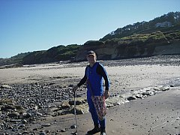 | 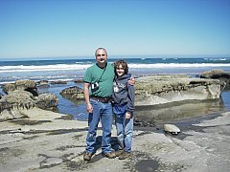
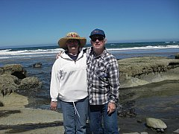 | 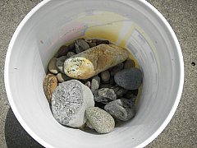

Barb Parker
Millennium Diggers Secretary

